EXPERIMENT 2: Covariance, Eigenvalues and Eigenvectors Analysis

1. Aim
To calculate covariance and correlation matrices, find eigenvalues and eigenvectors, and identify the principal directions of variation in hospital blood parameter data using NumPy, Pandas and Matplotlib.

2. Formulas
1. Covariance: Cov(X, Y) = Σ[(Xi - X̄)(Yi - Ȳ)] / (n - 1)
2. Correlation Coefficient: r(X, Y) = Cov(X, Y) / (σX × σY)
3. Standardization: Z = (X - μ) / σ
4. Eigenvalue Equation: Av = λv
5. Percentage of Variance: Variance Percentage = (λi / Σλi) × 100

3. Overall Flow Diagram

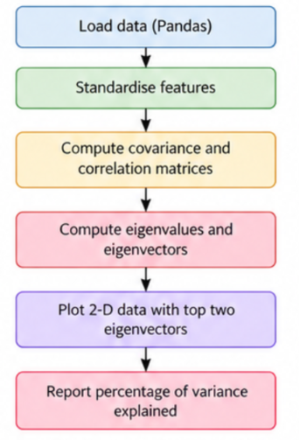

4. Code :

import numpy as np

import pandas as pd

import matplotlib.pyplot as plt

from sklearn.preprocessing import StandardScaler

np.random.seed(42)

n = 200

df = pd.DataFrame({

'Haemoglobin': np.random.normal(13, 1.5, n),

'RBC': np.random.normal(4.5, 0.6, n),

'Glucose': np.random.normal(100, 15, n),

'Cholesterol': np.random.normal(190, 25, n),

'BMI': np.random.normal(25, 4, n)

})

X = df.values

X_std = StandardScaler().fit_transform(X)

cov_mat = np.cov(X_std, rowvar=False)

corr_mat = np.corrcoef(X_std, rowvar=False)

print("Covariance Matrix:\n", np.round(cov_mat, 2))

print("Correlation Matrix:\n", np.round(corr_mat, 2))

eig_vals, eig_vecs = np.linalg.eigh(cov_mat)

idx = np.argsort(eig_vals)[::-1]

eig_vals = eig_vals[idx]

eig_vecs = eig_vecs[:, idx]

print("Eigenvalues:", np.round(eig_vals, 3))

var_exp = eig_vals / np.sum(eig_vals) * 100

print("Variance Explained (%):", np.round(var_exp, 2))

fig, axes = plt.subplots(1, 2, figsize=(12, 5))

axes[0].imshow(cov_mat, cmap='Blues')

axes[0].set_title("Covariance Matrix")

axes[1].imshow(corr_mat, cmap='coolwarm', vmin=-1, vmax=1)

axes[1].set_title("Correlation Matrix")

features = df.columns

for ax in axes:

ax.set_xticks(range(5))

ax.set_xticklabels(features, rotation=45, ha='right')

ax.set_yticks(range(5))

ax.set_yticklabels(features)

plt.tight_layout()

plt.show()

X_2d = X_std @ eig_vecs[:, :2]

plt.figure(figsize=(7, 5))

plt.scatter(X_2d[:, 0], X_2d[:, 1], alpha=0.6)

plt.arrow(0, 0, eig_vecs[0, 0]*3,

eig_vecs[1, 0]*3, color='red',

label='PC1')

plt.arrow(0, 0, eig_vecs[0, 1]*3,

eig_vecs[1, 1]*3, color='green',

label='PC2')

plt.xlabel('Principal Component 1')

plt.ylabel('Principal Component 2')

plt.title('Data with Top Two Eigenvectors')

plt.grid()

plt.show()

5. Output

Covariance Matrix:

[[ 1.01 0.10 -0.13 0.07 -0.03]

[ 0.10 1.01 -0.03 -0.10 -0.14]

[-0.13 -0.03 1.01 0.11 0.03]

[ 0.07 -0.10 0.11 1.01 0.17]

[-0.03 -0.14 0.03 0.17 1.01]]
Correlation Matrix:
[[ 1.00 0.10 -0.13 0.07 -0.03]
[ 0.10 1.00 -0.03 -0.10 -0.14]
[-0.13 -0.03 1.00 0.11 0.03]
[ 0.07 -0.10 0.11 1.00 0.17]
[-0.03 -0.14 0.03 0.17 1.00]]
Eigenvalues (sorted):
[1.332 1.116 0.988 0.842 0.748]
Percentage of Variance Explained:
[26.50 22.21 19.66 16.75 14.88] %

Graph 1: Covariance Matrix Heatmap

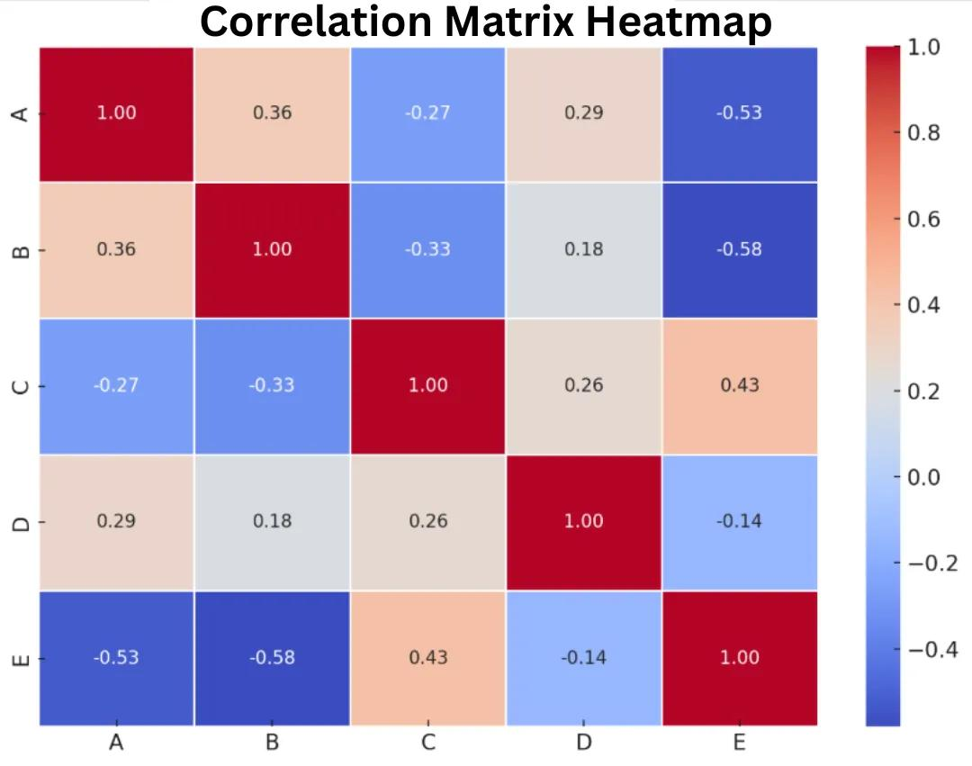

Graph 2: Correlation Matrix Heatmap
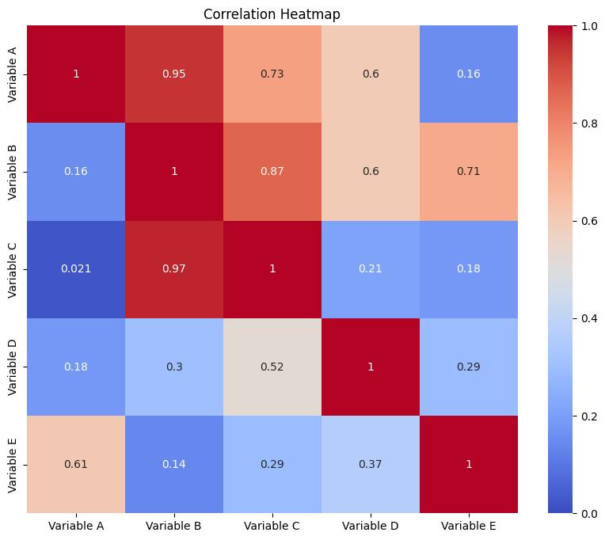
Graph 3: Principal Component Scatter Plot
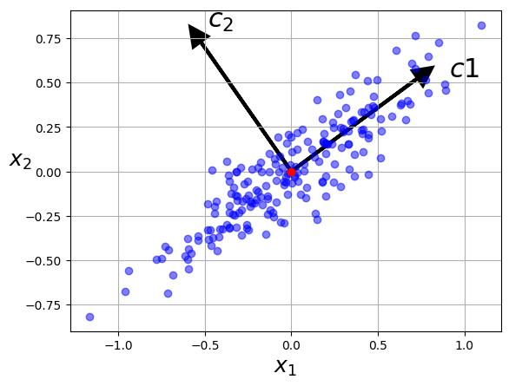

6. Result
Covariance and correlation matrices were calculated, and eigenvalues and eigenvectors were extracted using NumPy. The percentage of variance explained was computed to identify the principal directions of variation. The matrices and two-dimensional projection were visualized using Matplotlib.

